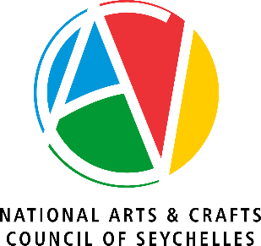

INVITATION TO TENDER

The National Arts and Crafts Council (“NACC”) invites tenders for the Procurement of One (1) Sport Utility Vehicle (SUV).

Source of finance: | Government of Seychelles
Eligibility: | The following are eligible to tender on equal terms. All licensed Motor Vehicle dealers operating in Seychelles.
Subject: | Vehicle is to be used for administrative duties, staff transportation for official  engagements, outreach programme, inspections, site-visits and compliance activities.
Period of Delivery: | Three (3) Months from the date of the award of contract.
Access to tender Dossier: | The Tender Dossier can be obtained at the National Arts and Crafts Council, Stad Popiler Car Park, Victoria between 09:30am to 3:30pm or by emailing ao@nacseychelles.sc cc; dhrbm@nacseychelles.sc as from Thursday 7th May 2026.
Closing date for Dossier: | The closing date for obtaining the tender dossier is Wednesday 13th May 2026 at 3:30pm.

Note: The tender documents are to be given to interested bidders for free.

Submission of Tenders:

TENDERS MUST BE SUBMITTED TO THE NATIONAL TENDER (NTB) SECRETARIAT BY ACCESSING THE PORTAL https://www.ntb.sc/tenders/nacc-procurement-of-one-1-sport-utility-vehicle-suv WHICH CAN BE FOUND ON THE NTB’s WEBSITE NOT LATER THAN 11:00AM (SEYCHELLES TIME) ON THURSDAY 21ST MAY 2026. THE BIDDERS ARE REQUESTED TO CLEARLY STATE THE PROJECT TITLE “PROCUREMENT OF ONE (1) SPORT UTILITY VEHICLE (SUV)”,

TENDERS WILL BE OPENED IMMEDIATELY AFTER CLOSING ON THURSDAY 21ST MAY 2026 AT 11:00AM (SEYCHELLES TIME) AT THE NATIONAL TENDER BOARD (NTB) SECRETARIAT, ATTIC FLOOR, CARE HOUSE, VICTORIA, MAHE, SEYCHELLES. BIDDERS OR THEIR REPRESENTATIVES ARE WELCOME TO ATTEND THE TENDER OPENING SESSION.

ANY BID RECEIVED AFTER THE DEADLINE WILL NOT BE ACCEPTED AND WILL BE RETURNED UNOPENED TO THE BIDDER.

Interested bidders can also view this notice on www.pou.gov.sc or www.ntb.sc

All enquiries regarding the tender should be addressed to the Administrative Officer, National Arts and Crafts Council, Stad Popiler, Victoria, Mahe, Seychelles, Tel: +2484295200, Email: ao@nacseychelles.sc cc; dhrbm@nacseychelles.sc

